Krzysztof Kutt
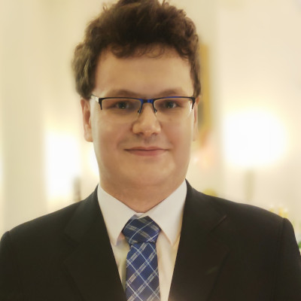Krzysztof Kutt
Krzysztof Kutt, PhD (krzysztof.kutt@uj.edu.pl, www) is an assistant professor at the Faculty of Physics, Astronomy and Applied Computer Science, Jagiellonian University, Kraków, Poland.
He has received his MSc degree in Computer Science from AGH UST in 2013. In 2018, he finished his PhD thesis in which he prepared methods and tools for collaborative knowledge engineering. He also received MA degree in Psychology from Jagiellonian University in 2016. In his master thesis he designed prefrontal EEG alpha waves neurofeedback training to enhance the athletes' effectiveness during the competitions.
Currently, as a computer scientist and psychologist, he tries to combine expertise from both disciplines into something cool. His research activity focuses on the development of affective HCI/BCI interfaces (based on multimodal fusion of signals and contextual data), methods for processing sensory data (including semantization of such data) and the development of knowledge-based systems (in particular knowledge graphs and semantic web systems).
He was involved in a variety of research projects and activities. For overview, see research page. For the list of his publications see papers page.
In his free time he reads sci-fi, fantasy and non-fiction, rides a bike and tries to learn something new.

More GEIST
→ Meet the whole team.

