Michał Kuk
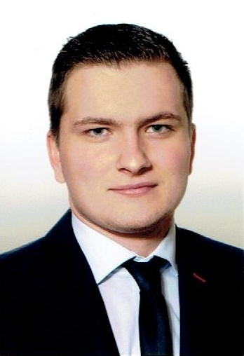Michał Kuk
Michał Kuk is a graduate of the AGH University of Science and Technology from the Drilling, Oil and Gas Faculty. In 2017, realized his master's thesis in which he developed an algorithm optimizing the location of new wells. In 2018, he started Ph.D. studies at the same faculty with a specialization in mining and geology. His scientific researches are connected with the optimization of oil and gas production. He uses machine learning algorithms to improve production from the reservoirs. One of his methods has been presented on the SPE student paper contest where he took 2'nd place in the Ph.D. division. Since November 2020 he is a member of the GEIST team. He was involved in Process-aware Analytics Support based on Conceptual Models for Event Logs - PACMEL project and now he is participating in the XPM project (explainable predictive maintenance).

More GEIST
→ Meet the whole team.

