GEIST People

Team Coordination

Grzegorz J. Nalepa
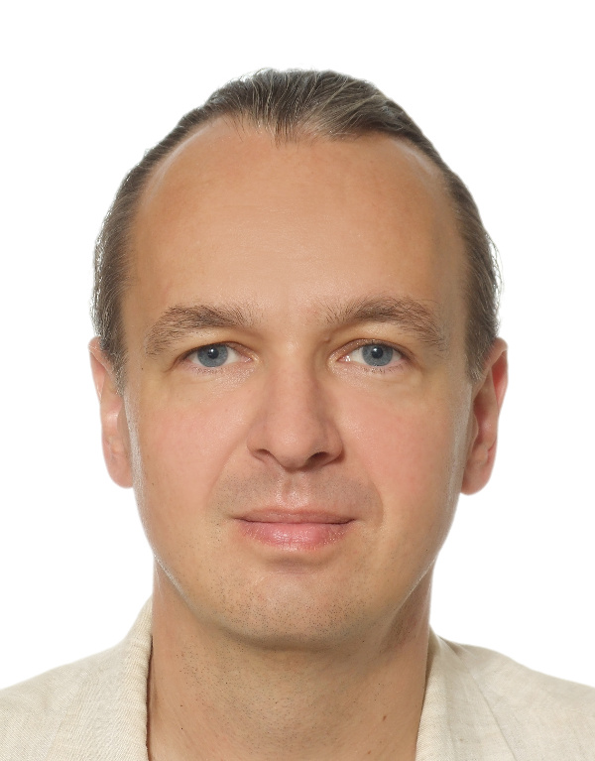
gjn@agh
GJN.re
short bio

Senior Associated Researchers
Antoni Ligęza  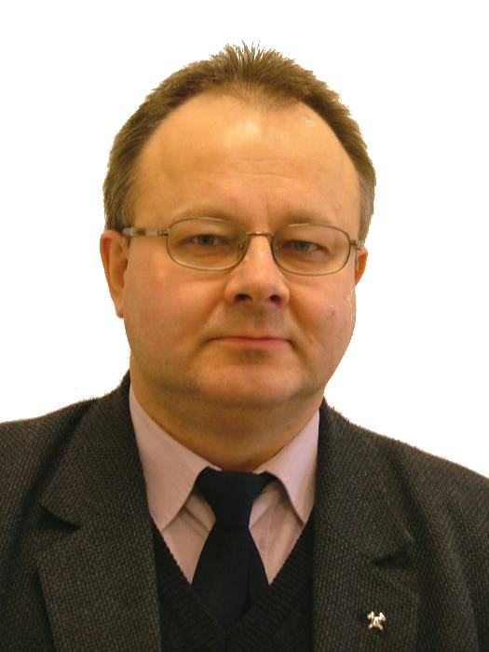  ligeza@agh  WWW  short bio | Marcin Szpyrka  mszpyrka@agh  WWW  short bio

Post Doctoral Researchers
Szymon Bobek  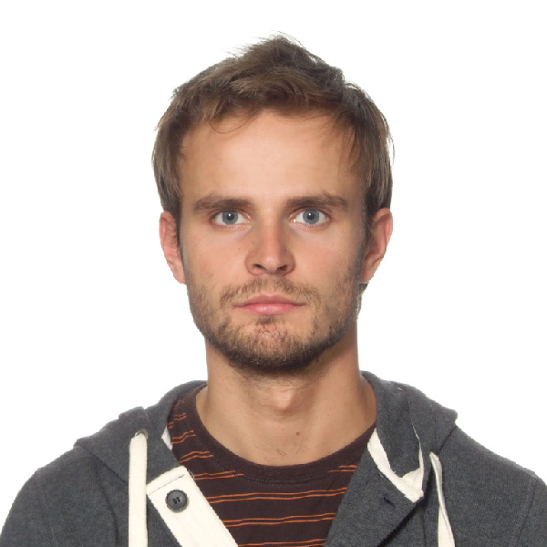  sbobek@agh  WWW  short bio | Krzysztof Kutt  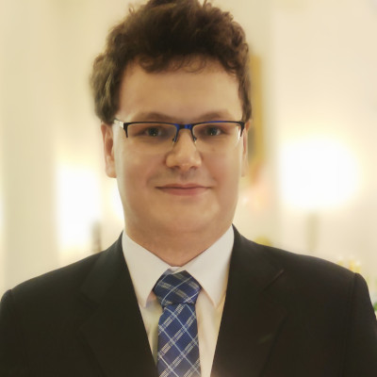  kkutt@agh  WWW  short bio

PhD Researchers
Mateusz Ślażyński  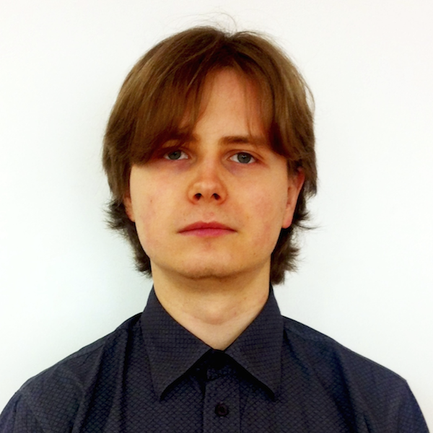  mslaz@agh  WWW  short bio | Paweł Jemioło  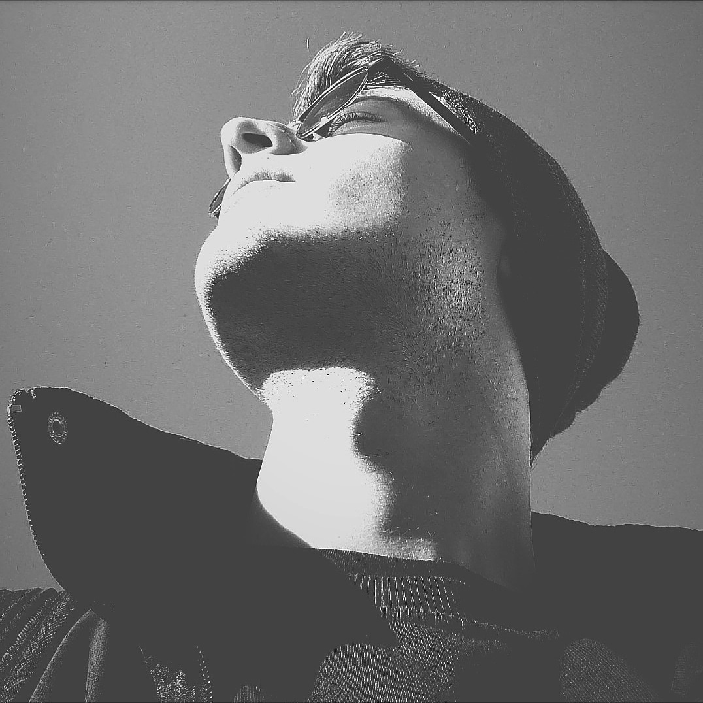  pjm@agh  WWW  short bio | Maciej Szelążek  FIXME  WWW  short bio

Michał Wypych    mwypych@agh  WWW  short bio | Barbara Giżycka  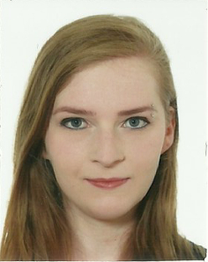  bgizycka@agh  WWW  short bio | Mateusz Z. Łępicki    mzl@agh  WWW  short bio

Guests and Interns
Víctor Rodríguez Fernández  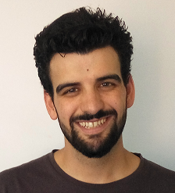  mail  Google Scholar  short bio | Dominika Drążyk  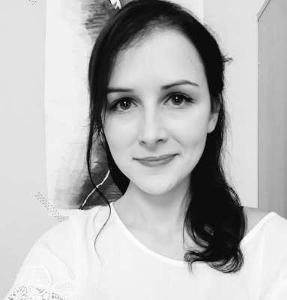  mail  ResearchGate  short bio | Kacper Łodziński  FIXME  WWW  short bio

Hall of Fame: Former/Inactive/Active-Elsewhere Researchers
Sławomir Nowaczyk  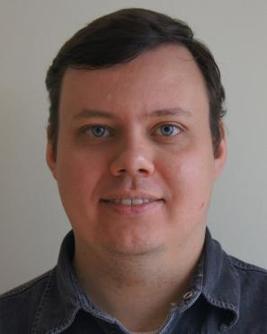  short bio  Now leading lab in Halmstad University, Sweden | Weronika T. Adrian  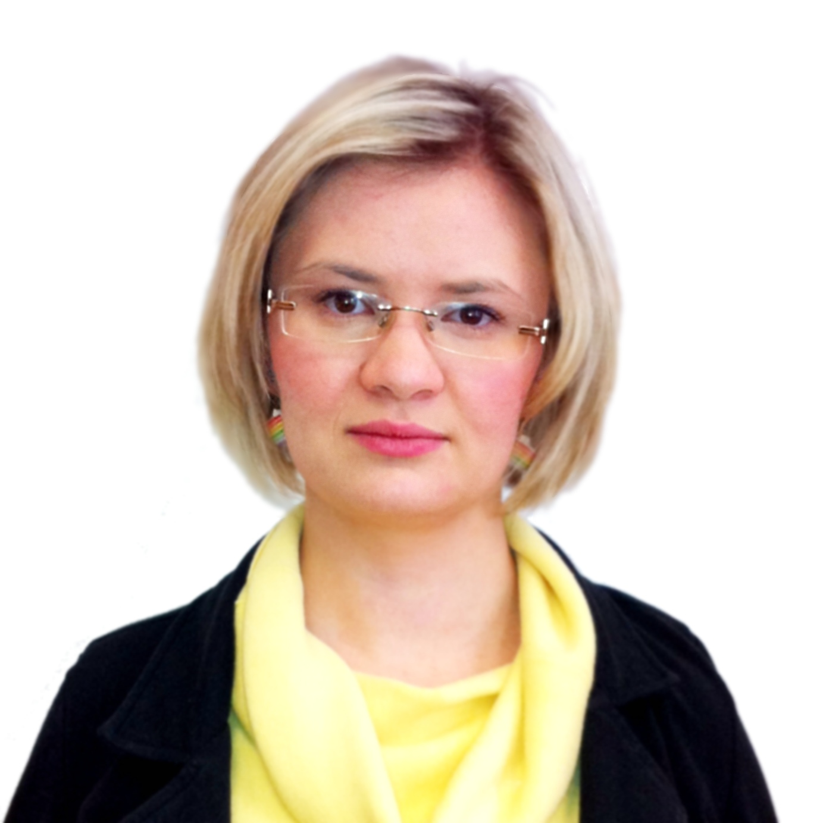  short bio  Now postdoctoral researcher in University of Calabria, Italy | Krzysztof Kaczor  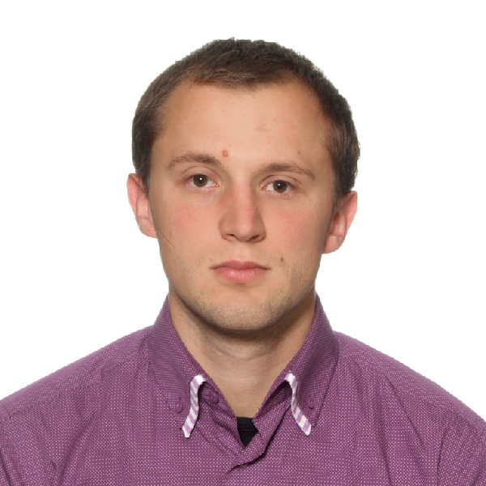  short bio  Gone for the industry.

Krzysztof Kluza
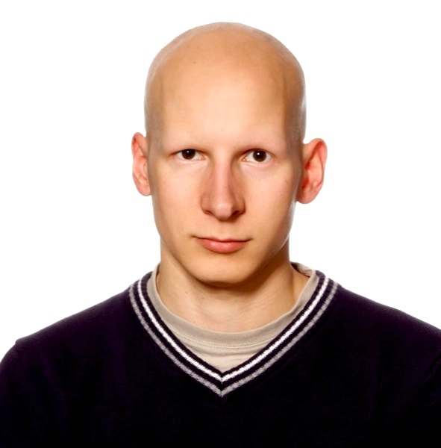
short bio
Lost in the Dean's office

Students
- Piotr Misiak
- Olgierd Grodzki
- Rafał Kułaga
- Radosław O. Milo
- Łukasz Łysik

