HiBuProBuRul
Methodology for designing Hierarchical Business Processes integrated with Business Rules (HiBuProBuRul)
- 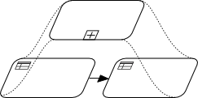Preludium 2 NCN Grant no. UMO-2011/03/N/ST6/00909
- Project Leader: mgr inż. Krzysztof Kluza
- Scientific Supervisor: dr hab. inż. Grzegorz J. Nalepa
- Start time: 05.09.2012
- Duration: 24 months

Motivation
The main objective of the HiBuProBuRul project is to develop an efficient method for design and integration of Business Processes with Business Rules. The problem is considered using the existing representation methods for processes and rules, specifically BPMN (Business Process Model and Notation) for Business Processes, and XTT2 (EXtended Tabular Trees version 2), which constitutes a formalized rule representation developed as a part of the SKE (Semantic Knowledge Engineering) approach.
Apparently there are two main persistent problems with the existing approaches to integration of Business Processes (BP) with Business Rules (BR):
- Semantic mismatch problem – a semantic mismatch between a general workflow (defined by Business Process)
and a specific task logic (defined using Business Rules).
- Structure hierarchization problem – lack of a hierarchical, standardized and coherent methodology
for designing systems using Business Processes with Business Rules.
The aim of the project is to address these problems by providing an efficient integration method and developing a hierarchical methodology for design and integration of these technologies. Such a design methodology fits into the MDE (Model-Driven Engineering) paradigm, which focuses on creating and exploiting domain models and simplifies the design process.

Results
Although Business Process and Business Rules technologies are an active field of research and development in the world, there is a lack of a coherent and standardized solution in the field of their integration. Our solution proposes the consistent methodology which uses the BPMN notation for modeling Business Processes with logic tasks defined using Business Rules based on SKE.

Benefits of the project
There are several benefits of the project:
- Conceptual: A hierarchical design methodology combining BPMN Business Processes and SKE Business Rules developed in this project is a promising application of the MDE paradigm that eliminates a semantic mismatch between BP and BR, and the structure hierarchization problem.
- Practical: The results of the project conceptually contribute to the Business Process and Business Rules field of research. From the practical point of view the proposed methodology can be further extended and adapted for applications.
- Evaluative: To show the effectiveness of the method, a number of case study examples were specified and modeled.

Results overview
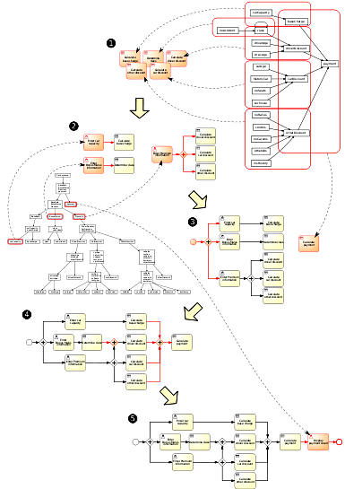
To accomplish the goal of the project, a formalized General Business Logic Model – a process model integrated with rules – was introduced. This integrated model was applied to combine a process model with the Semantic Knowledge Engineering approach in order to define the SKE-specific Business Logic Model. This is followed by the extension of the formalization of Attribute Relationship Diagrams, in order to describe the algorithm for automatic generation of Business Process models from ARD models (see Figure on the right). Using the algorithm, an executable process model can be generated along with decision table schemas for rules (rule templates for rule sets grouped in decision tables) – see Figure below. Such a model can be treated as a structured rule base that provides explicit inference flow determined by the process control flow. This approach fits well into the Model-Driven Engineering paradigm.
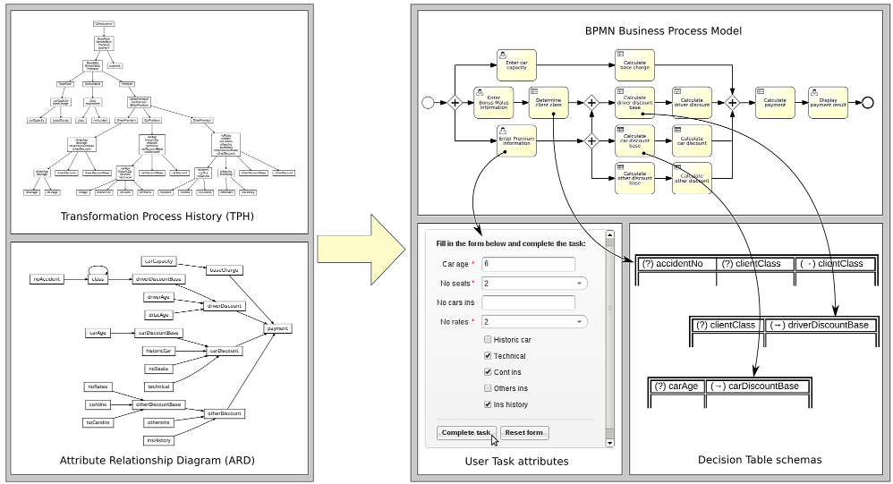
For the such integrated models the modeling and execution environment was provided (see Figure below).
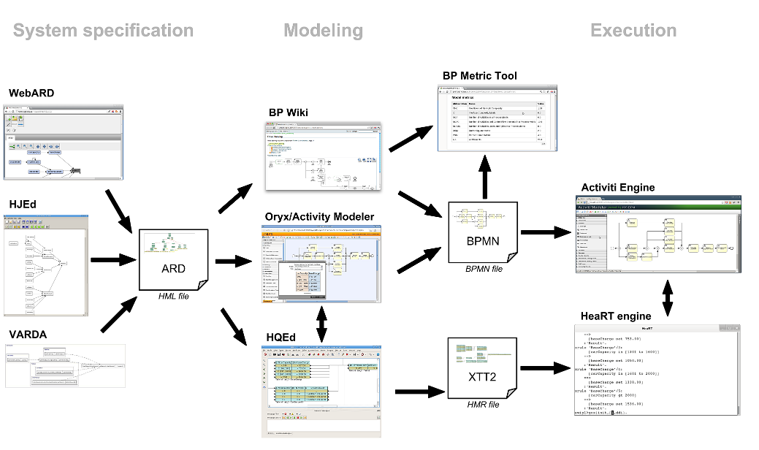
tag>project current_project
Go back to → projects

