Personality, Affective Context and the Brain (PANBA)
- Research minigrant in the DigiWorld Priority Research Area UJ, project no. U1U/P06/NO/02.02
- Project Leader: dr inż. Krzysztof Kutt
- Start time: 01.01.2021
- Duration: 17 months
- www: PANBA

Objectives
The PANBA project aims to continue the efforts made in BIRAFFE1 and BIRAFFE2 oriented towards developing methods for affective personalization of intelligent systems (for details, see the dedicated page at AfCAI wiki).
The scope of the work will be twofold.
The first part will be related to the analysis of data collected in previous experiments. We will verify specific hypotheses concerning, e.g.,
- the relation between individual psychophysiological signals and emotions,
- the possibility of extracting high-level context from low-level logs from the experimental (game) environment,
- the modulation of emotional reactions by context,
- and the possibility of using personality profile as a factor for grouping people with different styles of emotional reactions,
which will facilitate the adaptation of games (and intelligent systems in general) to particular (groups of) users.
The second part of the work will be related to the preparation of the next version of the experiment (BIRAFFE3) based on the conclusions drawn from the analyses and the review of current literature on the subject. One of the basic assumptions concerning BIRAFFE3 is the extension of the set of recorded signals to include brain activity (EEG), which is the third basic signal (next to ECG and GSR already present in previous work) used to predict emotional changes.

Devices and materials
With the grant funds we were able to purchase the equipment and materials needed for the third edition of the BIRAFFE3 experiment:
- The most important from the point of view of the project objectives is the purchase of the mobile EEG headset Unicorn Hybrid Black, developed by g.tec – the well-known manufacturer of research grade EEG systems. What is important, this headset is both mobile (communicates via bluetooth) and offers a reasonable quality of the collected signal (8 channels, 24-bit ADC, 250 Hz sampling), which is superior to the cheapest solutions, e.g. Emotiv EPOC+.
- Sony DualShock 4 gamepads for procedure control and accelerometer data acquisition
- Creative Live! Cam Sync 1080p V2 cameras to collect facial expressions for subsequent emotion analysis
- Personality questionnaires: in addition to the NEO-FFI determining the Big Five personality traits, we also decided to buy and use the Eysenck questionnaire (EPQ-R)
- Disposable materials: electrodes for ECG/EEG/GSR, gel for EEG electrodes, disinfectants and others
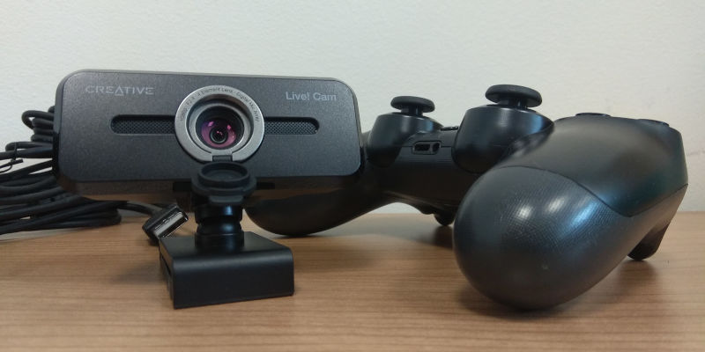
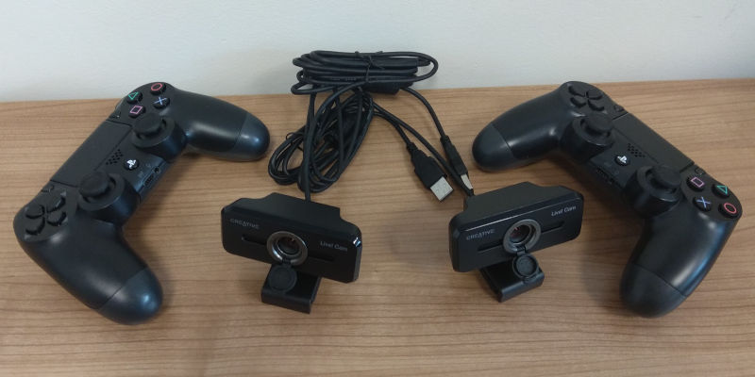
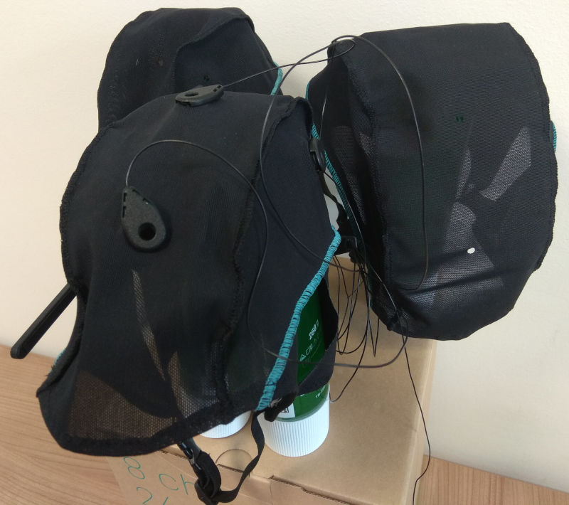
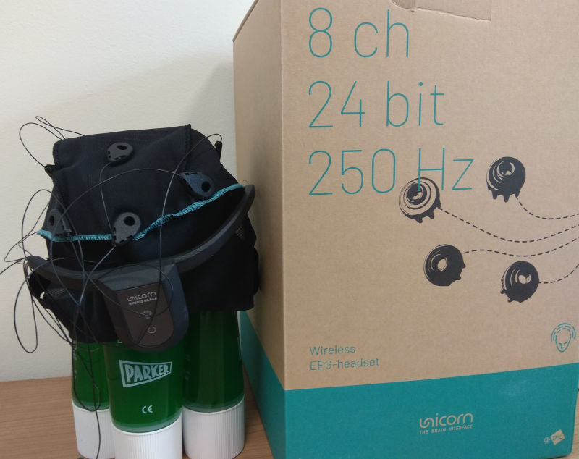

Publications
The results of the research are described in the following publications:
- L. Żuchowska, K. Kutt, and G. J. Nalepa, “Bartle Taxonomy-based Game for Affective and Personality Computing Research,” in Twelfth International Workshop Modelling and Reasoning in Context (MRC) @IJCAI 2021, 2021, pp. 51–55.
- K. Kutt, L. Żuchowska, S. Bobek, and G. J. Nalepa, “People in the Context – an Analysis of Game-based Experimental Protocol,” in Twelfth International Workshop Modelling and Reasoning in Context (MRC) @IJCAI 2021, 2021, pp. 46–50.
More publications coming soon!

