ResSConx
Methods for Semantic Representation and Logical Reasoning in Context-Aware Systems (ResSConx)

Description

Research project objectives and research hypothesis
Context-aware systems have been studied in several fields and developed for over 30 years. However, they are still identified as being one of the main trends that will change IT and the economy in the next 10 years. In this research project, the following research objectives related to context-aware systems are addressed:
- semantic context representation: representing context on a semantic level (i.e. its conceptual meaning) suitable for logical reasoning and adaptable to the changing environment by the use of machine learning;
- logical context reasoning: providing an expressive and tractable logical representation for context knowledge base allowing for the use of context for different user-oriented goals;
- design and deployment of context-aware systems: considering a model-driven design and deployment of service-oriented context-aware systems; proposing context-driven design patterns and deployment schemes suitable for adaptable systems.
- unified context handling for system adaptation: providing a holistic
view of context-aware systems based on the user-centric perspective, considering pervasive mobile platforms, and cloud-based service-oriented business applications as complementary components of a context aware system, with patterns for the development of context-aware multimodal user interfaces.
Based on these observations, in this proposal we argue for the following research hypotheses:
- Context modeling methods should be semantic. Context information has to be represented, modeled and processed on a purely semantic level in order to capture the meaning and be relevant to the user. It also has to be adjusted and improved over time and situation, with well established machine learning methods.
- Context-based reasoning should be done on a logical level. Advanced reasoning schemes based on rules and processes can be effectively employed to reason about situations in which the components of a context-aware system operate. Multiple inference scenarios meeting diverse user needs have to be considered.
- Design methods and deployment schemes should be context-driven. The design of a context-aware system should be model-driven, with models related to context representation and reasoning. Important deployment patterns for context-aware systems have to be identified.
- Context-oriented adaptability of a system is needed to meet expectations of diversified user base. We argue that context-oriented adaptation and user-centric perspective are features that bind together pervasive computing with mobile devices and distributed cloud-based and service-oriented software systems. Current features of multimodal interfaces need to be investigated and their potential exploited.
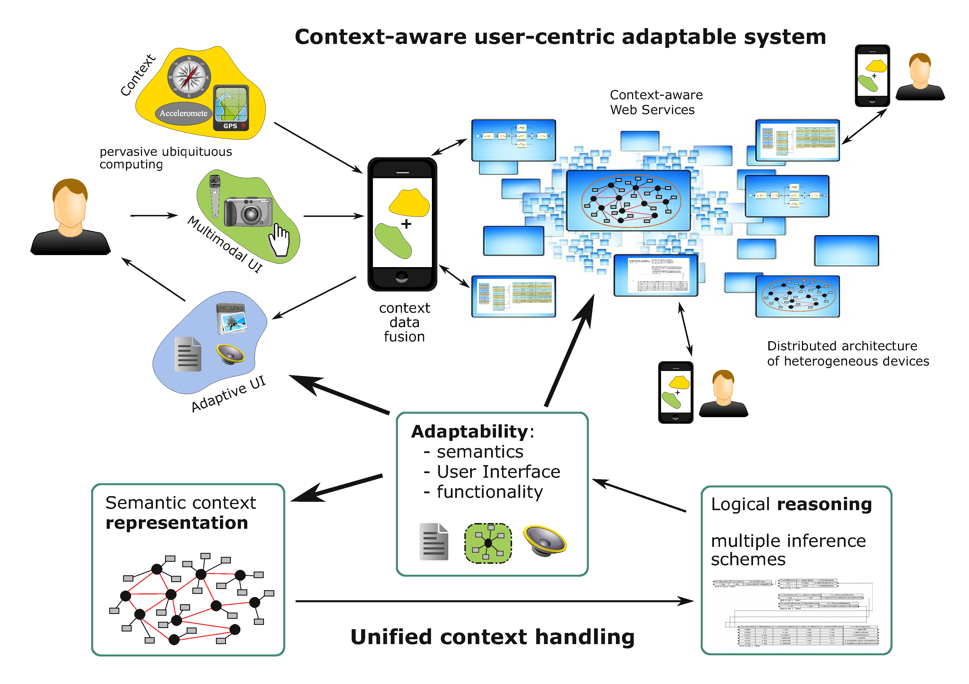

Research project methodology
The planned methodology will include both conceptual studies as well as experimental work in the form of proof-of-concept prototypes for the evaluation purposes. In order to achieve the project objectives, a number of methods will be used. They are well known to the authors who have successfully used them in their prior work.
Key methods will include knowledge representation and reasoning. For context modeling, we will mostly use the ontologies. Rule-based representation will play an important part in the project. We will use a rule representation developed in previous projects, called XTT2 (eXtended Tabular Trees). The concept of structured and possibly distributed rule bases will be applied to model concepts on the lower and situations on the higher level. For the reasoning tasks, mostly the HeaRT rule engine will be used. The engine has already been applied for reasoning in various environments and rule base is designed to be interpreted in several ways by using different inference modes. Moreover, in the project automatic verification features of the XTT2 knowledge bases will be used.
The machine learning techniques will be used to tune the rules in the decision tables that represent concepts, so that they will be made unambiguous. To model complex context situations we will take advantage of our experience in modeling workflows and business processes. They will serve as a useful tool for visual modeling of the system dynamics that helps in complexity management. The authors have also an extensive experience in the area of distributed system modelling and verification for multi-agent applications and embedded platforms, especially using Petri nets and the Alvis modeling language for parallel systems. They will be used for prototyping on mobile platforms.
The project will also take advantage of adaptable multimodal user interfaces, as not only a system, but also user interfaces need to be adapted with context and for given situation. The authors have an experience in adapting various user interfaces for human-computer interaction.
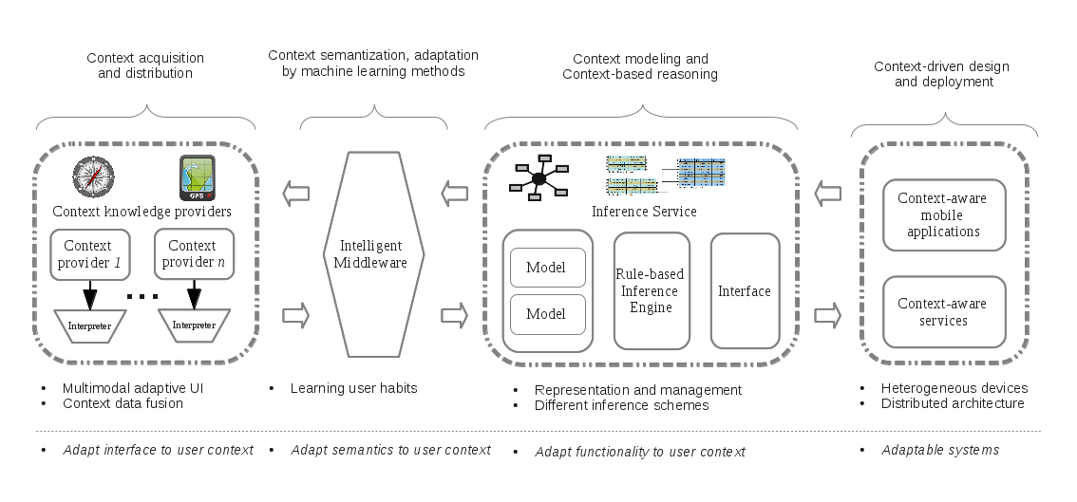

Context-oriented Adaptation Case Studies
The primary objective of this task is a careful study of selected classes of context-aware systems and well defined user interaction scenarios. The novelty of this attempt is that it emphasizes the system adaptation that will be achieved thanks to the proposed approach. In fact, we argue that context-oriented adaptation and user-centric perspective is what binds pervasive computing with ubiquitous mobile devices and distributed cloud-based and service-oriented software systems. The specific scenarios include:
1. Distributed network of mobile devices that build up a pervasive environment. We take into consideration hardware constraints, embedded devices, and soft-real time issues. We take the full advantage of the learning middleware that can adapt to habits of specific users and changing environment. We plan an evaluation setup that will consist of several smartphones, tablets and augmented reality glasses. In this environment the learning middleware capabilities will be tested and evaluated according to a device type and usage characteristics. Moreover, we will use a network server to gather, store and distribute the reference context data about the environment.
2. Cloud-based web service environment, where software agents play the dominant role. We will develop a service-oriented business applications that can be adapted in a number of ways, and the initial configuration is based on the deployment context. Then the adaptation allows for providing functionality tailored to the needs of specific users. We also focus on context-aware business objects and semantic web services composing a service mash-up. In this subtask we will use the network server a platform for web services as well as distribution of the context data.
3. Ambient office environment, using close range localization services such as Bluetooth of mobile devices (i.e. smartphones and tablets), to identify and localize personnel. We plan to use semantic memory tags implemented with either mobile devices or lightweight RFID infrastructure to describe the relevant objects in the environment. We also consider augmented reality interfaces, both lightweight (using cameras and screens of mobile devices) and in the form of augmented reality glasses to provide an adaptive and contextual user interface with knowledge fusion capabilities. The environment will be used for evaluating schemes of distributed and collaborative work of a team of persons supported by augmented reality setup.

News

Comments
tag>project
Go back to → projects

