SaMURaI
Semantic Method for Unified Rules Interoperability in Knowledge-Based Systems (SaMURaI)
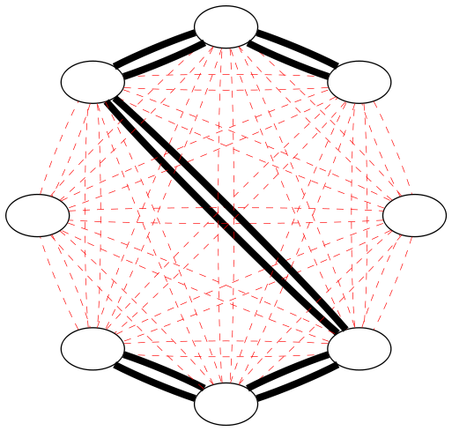
- Preludium 2 NCN Grant no. UMO-2011/03/N/ST6/00886
- Project Leader: mgr inż. Krzysztof Kaczor
- Scientific Supervisor: dr hab. inż. Grzegorz J. Nalepa
- Start time: 05.09.2012
- Duration: 24 months
- www: Strona www projektu

Motivation
The main objective of this project is to propose a new knowledge interoperability formalism for business rules. The motivation for this project involves the fact that existing technologies and languages for rule interchange (e.g. RIF, RuleML, R2ML, KIF) suﬀer from their general nature and complexity. Hence, their practical support is very difficult. What is more, existing Rule-Based System shells (e.g. CLIPS, Jess, Drools, OpenRules) provide different rule languages, which are merely only a programming solution. Even though the syntax of these languages is precisely defined, they rarely provide any underlying logical interpretation. This research aims at developing a unified business rule representation model which will play a key role in formulation of formalized methods for rule interoperability supported by tools.

Intended results
The most important results of this research include development of the formalized methods for rule interoperability. In this project the following rule languages are considered: CLIPS, Jess, Drools, OpenRules. Nevertheless, the proposed approach can be later extended to others rule languages. From the practical point of view, the project outcome will constitute a semantically coherent knowledge interoperability method for rules, which brings the following advantages:
- Uniﬁed logical interpretation of the common rule languages.
- Unequivocal knowledge exchange between rule language formats.
- Improved rule base maintenance methods.
Polish version
tag>project current_project
Go back to → projects

