Publications
You can browse and download GEIST members' recent publications related to the Bimloq project.
As well as the older publications concerning HeKatE in the AI Wiki.

GEIST members publications in AGH BPP system and DBLP
- prof. dr. hab. inż. Antoni Ligęza (DBLP)
- dr hab. Marcin Szpyrka (DBLP)
- dr inż. Grzegorz J. Nalepa (DBLP)
- dr inż. Sławomir Nowaczyk (DBLP)
- mgr inż. Krzysztof Kaczor
- mgr inż. Weronika T. Adrian (DBLP1, DBLP2)
- mgr inż. Krzysztof Kluza (DBLP)
- mgr inż. Szymon Bobek

Monographs
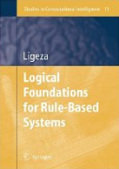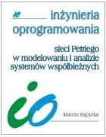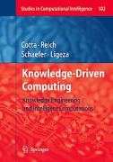
tag>xtt rule-based_systems prolog rules ai ard formal_analysis formal_methods

