Pellet-HeaRT
A prototype of a hybrid rule reasoner for ontologies.

Description
Integrating classic forward chaining rule reasoning implemented by HeaRT with the Pellet.
Concept by Grzegorz J. Nalepa and Weronika T. Adrian (Furmańska), prototype implementation by Weronika T. Adrian.

Idea
- Conceptual level: Integration of Attribute Logic with Set Values over Finite Domains (ALSV(FD)) and Description Logics (DL) (research papers on integration: here and here)
- Implementation level: Integration of Pellet ontology reasoner and HeaRT rule inference engine (research paper on architecture proposal: here, poster:
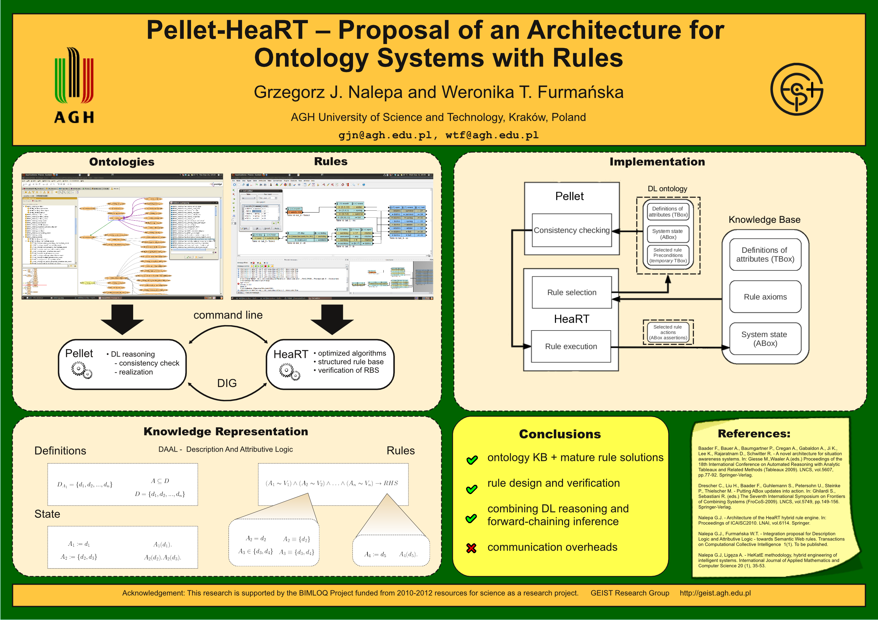poster

Integration Proposal
- Attributes in AL correspond to Concepts in DL
- model of a system stored in HeaRT, rule conditions checked by Pellet, execution of rules by HeaRT
- communication: DIG or command line

Implementation

Top-down overview
There are 2 aspects of the integration of Pellet and HeaRT:
- Communication channel
  - command line
    - sending RDF/XML (dedicated translators from HML/R to RDF/XML)
  - DIG interface
    - sending DIG message (dedicated translators HML/R to DIG)
- Inference scenario
  - rule precondition checked with consistency checking DL task
  - rule precondition checked with realisation DL task

What has been done
%%%%%%%%%%%%%%%%%%%%%%%%%%%%%%%%%%%%%%%%%%%%%%%%%%%%%%%%%%%%%%%%%%%%%
% Reasoning with HeaRT-Pellet: %
% 1. Build TBox: definitions of types and attributes %
% a) build additional statements: 'allDifferent' for individuals %
% 2. Call any inference mode you wish (GDI, TDI etc.) %
% 3. In each state build an ABox representing this state %
% 4. Whenever you check a rule preconditions: %
% a) build rule axioms (temporary TBox), %
% b) ontology = definitions TBox + rule axioms TBox + state ABox %
% c) send the ontology to Pellet to check its consistency %
% 5. Interpret the result, carry on as usual %
%%%%%%%%%%%%%%%%%%%%%%%%%%%%%%%%%%%%%%%%%%%%%%%%%%%%%%%%%%%%%%%%%%%%%
%%%%%%%%%%%%%%%%%%%%%%%%%%%%%%%%%%%%%%%%%%%%%%%%%%%%%%%%%%%%%%%%%%%%%
% Reasoning with HeaRT-Pellet - Alternative version: %
% %
% 1. Build TBox: definitions of types and attributes %
% a) build additional statements: 'allDifferent' for individuals %
% 2. Call any inference mode you wish %
% 3. In each state build an ABox representing this state %
% 4. Whenever you check a rule preconditions: %
% a) build rule axioms (ABox statements) %
% b) definitions TBox + rule axioms aBox + state ABox %
% c) send to Pellet to check realization the rule conditions %
% 5. Interpret the result, carry on as usual %
%%%%%%%%%%%%%%%%%%%%%%%%%%%%%%%%%%%%%%%%%%%%%%%%%%%%%%%%%%%%%%%%%%%%%
Following the inference scenario:
1. HeaRT can be started with additional parameter in the gox predicate:
%%%%%%%%%%%%%%%%%%%%%%%%%%%%%%%%%%%%%%%%%%%%%%%%%%%%%%%%%%%%%%%%%%%%%%%%%
% gox(StateIn,T,Mode,ExternalReasoner) %
% ExternalReasoner - the one used to check the rules preconditions %
% %
% Augmented version of Heart - additional variable for an ext.reasoner %
% %
%%%%%%%%%%%%%%%%%%%%%%%%%%%%%%%%%%%%%%%%%%%%%%%%%%%%%%%%%%%%%%%%%%%%%%%%%
2. Translating parts of the HMR model to RDF/XML
%%%%%%%%%%%%%%%%%%%%%%%%%%%%%%%%%%%%%%%%%%%%%%%%%%%%%%
% DAAL prototype translator.
% --------------------------
%
% Translates attributes into concepts,
% attribute values into instances and
% rule preconditions into T-Box like axioms.
%
% Supported operators: 'in', 'eq'.
% Supported attributes: 'symbolic'.
%
% Basic predicates:
% owl_xml_gen/0 - translate HMR file into DAAL representation (ontology).
% owl_xml_gen/1 - translate HMR file into DAAL representation (ontology)
% and write it to the file given as the argument.
% owl_xml_attr_gen/0 - translate the attribute definitions
% owl_rulp_gen/0 - translate the rules preconditions
% owl_rulp_gen/1 - translate the given rule preconditions
% owl_stat_gen/0 - translate the states statements
% owl_stat_gen/1 - translate the given state statement
%
%%%%%%%%%%%%%%%%%%%%%%%%%%%%%%%%%%%%%%%%%%%%%%%%%%%%%%
3. Sending partial ontologies from HeaRT to Pellet
4. Interpreting the Pellet answers by HeaRT

Technically
- heart-pellet.pl - Extended version of HeaRT (works with the standard HeaRT distribution): additional parameter in gox predicates for the external reasoner to use
- heart-daal-translator.pl - predicates

Papers
- G.J. Nalepa, W.T. Furmańska: Proposal of a New Rule-Based Inference Scheme for the Semantic Web Applications, New Challenges in Computational Collective Intelligence. Studies in Computational Intelligence, 2009, Vol. 244/2009, 15-26.
- G.J. Nalepa, W.T. Furmańska: Pellet-HeaRT – Proposal of an Architecture for Ontology Systems with Rules, KI 2010: Advances in Artificial Intelligence. LNCS, Vol. 6359/2010, 143-150.
- G.J. Nalepa, W.T. Furmańska: Integration Proposal for Description Logic and Attributive Logic – Towards Semantic Web Rules, TRANSACTIONS ON COMPUTATIONAL COLLECTIVE INTELLIGENCE II, LNCS, Vol. 6450/2010, 1-23.

Comments
No longer supported.
tag>software Semantic_Web ontologies rules
Go back to → software

