GEIST Spring of Code
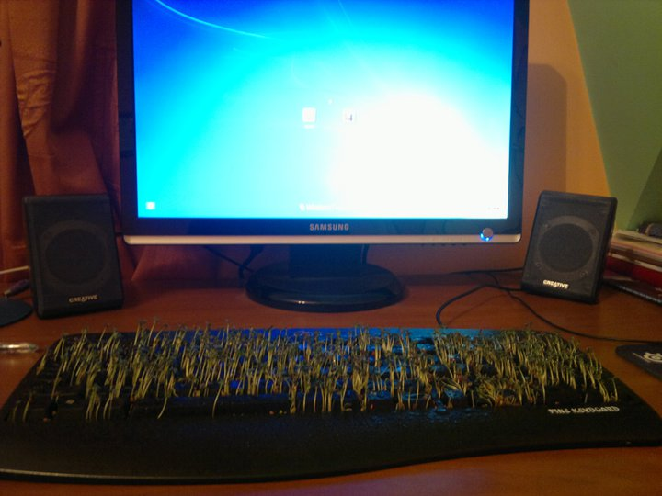
We work for students as their tutors on many different courses, but what is our real goal is to work with them!
Every year we look for ambitious students, who want to gain more knowledge and experience that it is offered on standard courses.
Most talented students will be able to:
- Gain knowledge and experience in the area of Artificial Intelligence that is not available on regular courses
- Work on their master or bachelor thesis and get paid for that
- Meet many famous people from the Artificial Intelligence society
- Implement their solutions in commercial products
- Continue their education on PhD studies
- Travel around the world
- Have a lot of fun
In exchange, we expect that students will:
- Be full of positive attitude
- Want to work (hard)
For more info, contact us!
Array

