Teaching

Labs and equipment
At the team disposal are two modern computer labs. In the labs a heterogeneous networking environment is provided with both GNU/Linux as well as other environments.
In 2008 a new robotics lab (Mobile Robots Laboratory) has been created. It is equipped with 12 LEGO Mindstorms NXT robotic sets and two mobile robots Hexor by Stenzel. The lab is being used to teach basics of intelligent robots control.
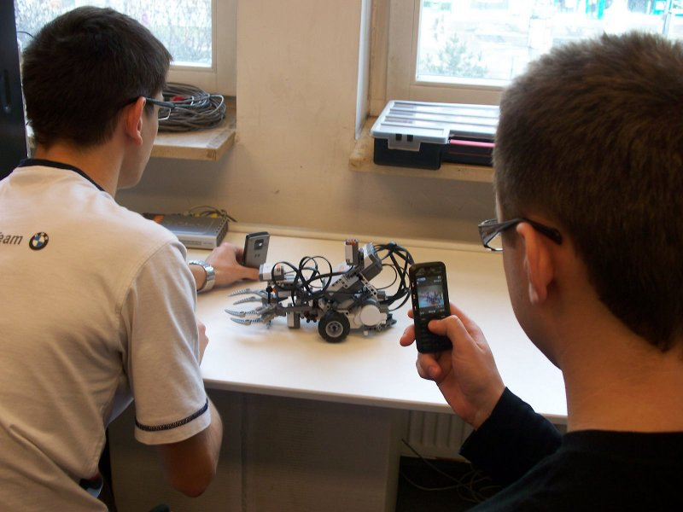Array
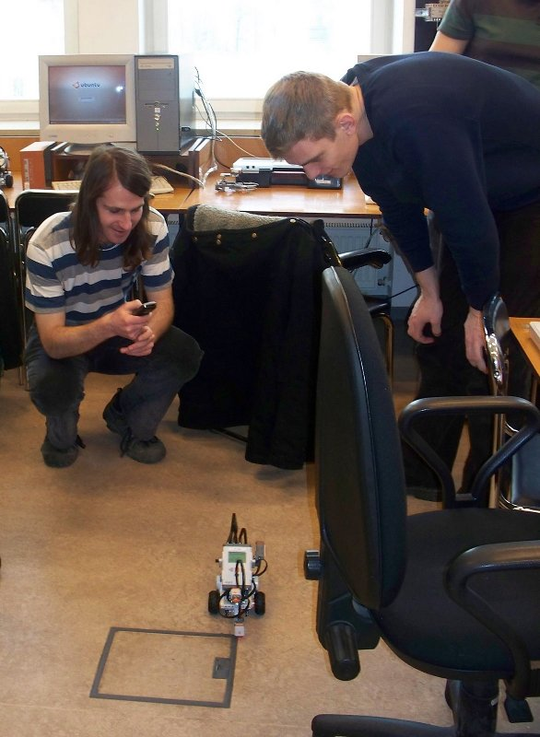Array
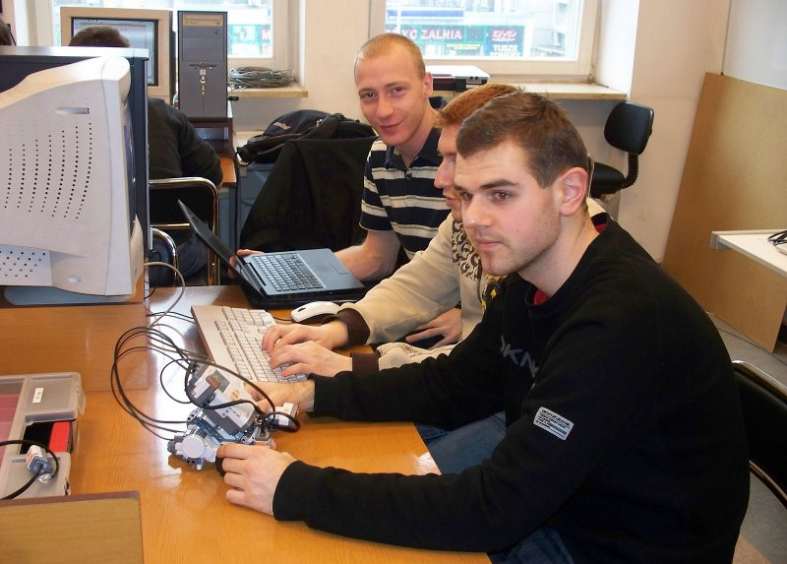Array
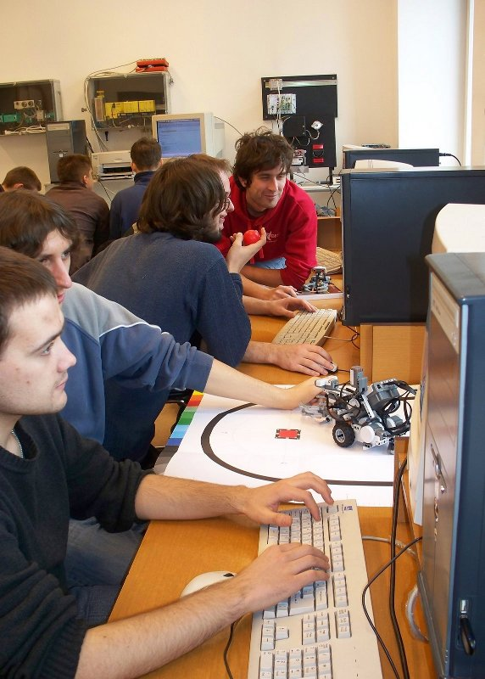Array
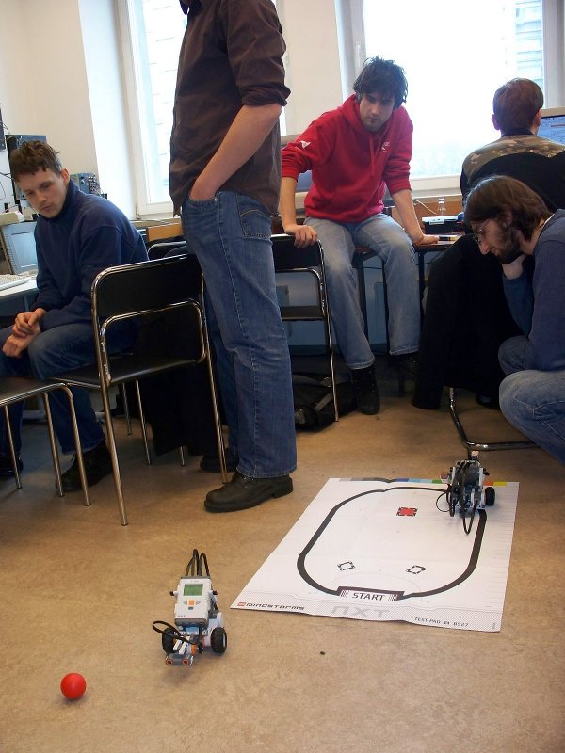Array
Array

